Title:
Button Debouncing

Use Case:
switches of other mechanical inputs often can have a lot of 'noise'. electrical mis-signaling that can cause a lot of problems with misreadings.

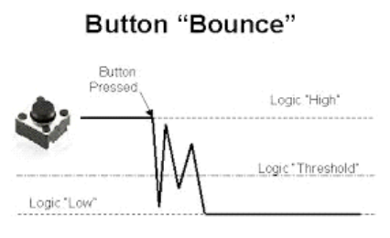

What this circuit does:
We can Debounce digital inputs, like buttons, in a lot of different ways. The most comprehensive of which is with a schmitt trigger:
" a Schmitt trigger is a logic input type that provides hysteresis or two different threshold voltage levels for rising and falling edge." https://en.wikipedia.org/wiki/Schmitt_trigger

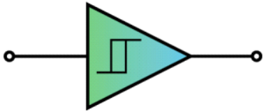

Basically, a schmitt trigger introduces an upper and lower threshold for reading a signal, instead of a single threshold. If the signal falls between the upper and lower limit, then the output signal remains the same(hysteresis). This acts like a buffer zone that cleans up even the dirtiest signal.

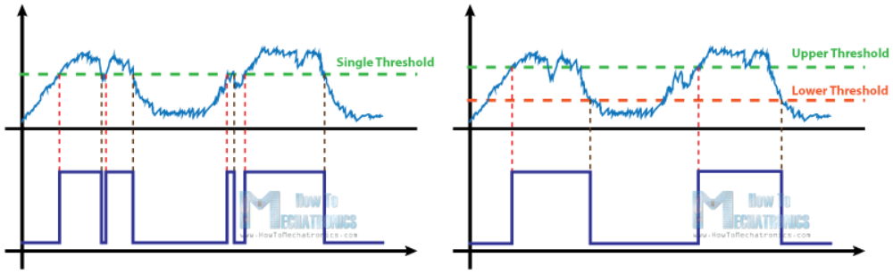

There are lots of ways to make schmitt triggers. The two most common are using an Operational amplifier, transistors, or a prebuilt schmitt trigger IC(recommended) like the SN74HC14N six-channel package (which can handle up to six buttons)

Key Parts:

SN74HC14N

